

**USKUDAR UNIVERSITY ★ FACULTY OF ENGINEERING AND NATURAL SCIENCES**

**Legacy of Legends**

**Khalid Ibn Al-Waleed**

**B.Sc. Thesis By**

**Mohammad Al-Rawas**

**Departement: Software Engineer**

**Supervisor (Chairman) : Prof. Dr. Salim Jibrin Danbatta**

**Members of the Examining Committee:**

**Prof. Dr. Kristin Surpuhi Benli**

**Prof. Dr. Belaynesh Chekol**

**11/June/2025**

**FOREWORD**

Without the guidance and unwavering support of Dr. Salim Jibrin Danbatta, this project would not have been possible. I am deeply grateful for his exceptional mentorship and steadfast assistance throughout my research journey. From the moment I presented my initial idea, Dr. Salim Jibrin Danbatta recognized its potential and encouraged me to pursue it wholeheartedly. His insightful feedback and constructive critique significantly shaped the course of my study, refined my arguments, and enhanced the quality of my work. I will forever value the opportunity to learn under his guidance and cherish the invaluable lessons and wisdom he imparted during this process.

June, 2025 Mohammad Al-Rawas

Software Engineer

Table of Contents

**1. Introduction 8**

1.1- Game Brief 8

1.2- Desing Pillars 8

1.3- Targeted Audience 8

1.4- Objectives 8

1.5- Current System 9

1.6- Problem Statement 9

1.7- Problem Solutions 11

1.8- Project Scope 12

1.9- Feasibility Study 13

**2. Methodology 15**

2.1- What is Scrum methodology? 15

2.2- Product Backlog: 16

2.3- Roles & Responsibilities: 17

**3. System Design 18**

3.1- Use-Case Diagram 18

3.2- Use-Case Description 20

**4. Implementation 23**

4.1- Menus: 23

4.2- Gameplay: 27

**5. Conclusion 34**

5.1- Game Summary: 34

5.2- Key Findings: 34

5.3- Future Work: 35

Table of Figures

Figure 1: Main Menu Use-Case 20

Figure 2: Gameplay Use-Case 21

Figure 3: Main Menu 25

Figure 4: Settings Menu 26

Figure 5: Pause Menu 27

Figure 6: Quest List Menu 28

Figure 7: In-Game Screen 1 29

Figure 8: In-Game Screen 2 30

Figure 9: Horse 31

Figure 10: Camel 31

Figure 11: Location-Based Quest 32

Figure 12: Combat-Based Quest 33

Figure 13: Cutscene 34

Figure 14: Quest Completed Notification 35

Table of Tables

Table 1: Hardware Feaseibility Study 13

Table 2: Software Feasibility Stude 14

Table 3: Main Menu Use-Case 22

Table 4: Gameplay Use-Case 23

**Legacy of Legends: Khalid Ibn Al-Waleed**

**SUMMARY:**

Is an immersive RPG game that follows the legendary life of Khalid Ibn Al-Waleed, a renowned military commander of the Islamic world. Players will navigate through pivotal moments of Khalid's life, from his early days as a fierce warrior to his strategic brilliance in leading conquests. With dynamic combat systems and pivotal cutscenes, players will experience the challenges and triumphs of one of history's greatest military leaders.

**Efsanelerin Mirası: Halid Bin Velid**

**ÖZET:**

Efsanevi İslam dünyasının ünlü askeri komutanı Halid Bin Velid'in hayatını konu alan, sürükleyici bir RPG. Oyuncular, Halid'in cesur bir savaşçı olarak erken dönemlerinden, fetihlere liderlik ederken sergilediği stratejik dehasına kadar hayatının önemli anlarını yaşayacaklar. Dinamik dövüş sistemleri ve etkileyici ara sahnelerle, oyuncular tarihin en büyük askeri liderlerinden birinin zorluklarını ve zaferlerini deneyimleyecekler.

1. **Introduction**
   1. **Game Brief**

"Legacy Of Legends: Khalid Ibn Al-Waleed "

Is an immersive RPG game that follows the legendary life of Khalid Ibn Al-Waleed, a renowned military commander of the Islamic world. Players will navigate through pivotal moments of Khalid's life, from his early days as a fierce warrior to his strategic brilliance in leading conquests. With dynamic combat systems, intricate political manoeuvres, and moral dilemmas, players will experience the challenges and triumphs of one of history's greatest military leaders!

* 1. **Desing Pillars**

Historical RPG: Historical RPG is a video game genre where players assume the roles of characters living in a particular historical period, often based on real events, locations, and figures. These games strive to create an immersive experience by accurately depicting the storyline of a character and conflicts of a specific era. They combine elements of traditional RPGs, such as character development, quest-based progression, and story-driven gameplay, with a strong focus on historical authenticity and educational content.

Action: An action game is a video game genre that emphasizes physical challenges, including hand-eye coordination, quick reflexes, and precision timing. The core of an action game is fast-paced gameplay, where players navigate a character through various levels, defeating enemies, overcoming obstacles, and often completing specific objectives. Action games are known for their intensity, with an emphasis on combat, movement, and engaging gameplay mechanics that keep players immersed in the experience.

* 1. **Targeted Audience**

- The new generation adults.

- People who want to know more about Islamic history.

- Lovers of history and historical wars.

- Khalid Ibn Al-Waleed fans.

- Historical RPGs gamers.

* 1. **Objectives**
* A game that aims to set a new standard in historical RPGs by blending engaging gameplay with rich storytelling and educational value. This unique approach not only honours Khalid’s legacy but also introduces players to a pivotal era in history that has been largely overlooked in gaming.
* Experience the extraordinary journey of Khalid Ibn Al-Waleed, from his birth and upbringing to his pre-Islamic life, his profound conversion to Islam, relentless battles against apostasies, conquering the two greatest empires at that time the Persian and the Roman empires, culminating in the historic Battle of Yarmouk which is revered as a pinnacle in Islamic and world history, and the serene twilight of his life preceding his departure from this world.
* Explore the depths of history, with a focus on Islamic one, to uncover the intricate layers of beauty inherent in Islam. Discover its profound teachings on peace, illuminating why it is revered as a pinnacle of spiritual enlightenment among religions worldwide.
  1. **Current System**

In the current landscape of historical RPGs, there are a limited number of games that dive into the lives of significant Islamic figures or explore the rich history of early Islamic conquests. While the gaming industry has produced numerous RPGs based on Western or Eastern historical periods such as the Roman Empire, Medieval Europe, and feudal Japan, there is a notable absence of games that focus on the early Islamic period. Existing games like Assassin’s Creed touch briefly on Islamic history but often in a fictionalized or generalized manner that lacks depth in representing key historical figures accurately.

Presently, RPG games that feature military commanders tend to highlight figures from popularized historical narratives and often focus more on gameplay mechanics than on historical accuracy or cultural depth. There is little emphasis on figures whose contributions shaped global history outside of Western or highly mythologized narratives, leaving a gap in representation for influential leaders such as Khalid Ibn Al-Waleed. Furthermore, many games that aim to educate players about history often sacrifice engaging gameplay, which can detract from the overall experience and limit their appeal.

This absence presents a missed opportunity to immerse players in the life and legacy of Khalid Ibn Al-Waleed, renowned for his unmatched military strategies and significant role in shaping the early Islamic period. A game dedicated to his life would not only be innovative in its historical focus but also educational, allowing players to experience the intense battles, strategic manoeuvres, and personal journey of Khalid. By combining accurate historical cutscenes with engaging gameplay mechanics, this RPG can introduce players to a meaningful and underrepresented aspect of world history, fulfilling an unmet need in the current system of historical RPGs.

* 1. **Problem Statement**
* Limited Related Games: The current gaming industry lacks historical RPGs that accurately represent and bring to life key figures from early Islamic history. Despite the vast potential for an immersive storytelling and educational value, few games explore the lives and achievements of historical figures outside of popularized Western narratives. This absence not only limits cultural representation but also misses the opportunity to engage players with the rich strategic and moral dimensions of figures like Khalid Ibn Al-Waleed, known as one of the greatest commanders of all time.

Existing historical games that attempt to cover Islamic history or Middle Eastern settings often rely on generalized or fictionalized representations, lacking the depth and accuracy needed to truly understand the historical significance of these characters and events. This gap in the market highlights a need for an RPG that combines engaging gameplay with historical authenticity, allowing players to experience the achievements, challenges, and legacy of Khalid Ibn Al-Waleed in a way that is both informative and entertaining.

* No Expensive Equipment: Independent or solo game developers face significant challenges in creating high-quality RPGs without access to the advanced equipment and resources typically available in professional game studios. High-end hardware, motion capture systems, and professional-grade sound and graphics tools are often prohibitively expensive, limiting the ability of smaller teams to achieve the same level of visual fidelity, fluid animations, and immersive soundscapes found in games developed by major studios.

This lack of access can hinder the development of complex, visually rich historical RPGs, where detailed character models, realistic environments, and nuanced animations are essential for delivering an engaging and authentic player experience. Consequently, the absence of affordable, high-quality resources makes it difficult for independent developers to create games that meet the high expectations of today’s gaming audience. This gap highlights the need for alternative solutions and creative approaches that allow developers to produce impactful and visually compelling games without the financial burden of a studio level equipment.

* Limited Designing Knowledge: For solo game developers with a programming background, creating detailed and visually engaging maps and environments can be a significant hurdle due to the lack of access to professional designers. Effective level design requires expertise in visual aesthetics, environmental storytelling, and spatial composition which are skills that are typically honed through specialized training and experience in game design. Without these resources, solo developers may struggle to create intricate, historically accurate maps that are both visually appealing and gameplay friendly.

This limitation is especially challenging for historical RPGs, where immersive environments play a crucial role in transporting players to another time and place. The absence of professional design support means that the developer must invest considerable time and effort into learning new design tools and techniques, often at the expense of core game development tasks. Consequently, solo developers face a gap between their technical capabilities and the aesthetic demands of modern games, underscoring the need for accessible design resources and tools that can help bridge this expertise gap and bring historical settings to life.

* 1. **Problem Solutions**
* Limited Related Games:

Collaborate with Historians and Cultural Experts: Partner with scholars and historians specializing in Islamic and Middle Eastern history to ensure historical accuracy and authentic representation. Incorporate real events, settings, and cultural nuances into the game narrative to make it both engaging and educational.

Blend History with Universal Appeal: Combine the depth of historical storytelling with universally engaging gameplay mechanics, such as strategy, character development, and moral decision-making, to attract a diverse audience.

Leverage Storytelling Platforms: Use crowdfunding platforms or partnerships with educational institutions to secure funding and raise awareness about the need for culturally diverse games. Market the game as both entertainment and an educational tool.

Incorporate Realism through Modding Communities: Involve modding communities in creating content that reflects authentic historical events and settings, which can reduce development time and cost while adding depth to the game.

* No Expensive Equipment:

Utilize Open-Source or Affordable Tools: Take advantage of free or low-cost game engines (e.g. Unreal Engine), asset libraries, and animation tools that offer professional-level quality without high costs.

Procedural Generation for Environments: Use procedural generation techniques to create expansive, realistic environments without manually designing every detail. This approach saves time and resources while maintaining quality.

Focus on Stylized Art: Instead of striving for photorealism, opt for a stylized art direction that is visually appealing and less resource-intensive to develop. This can make the game stand out aesthetically while reducing the need for expensive equipment.

Leverage AI and Automation: Use AI-powered tools to streamline asset creation, character animations, and environmental modeling. These tools can significantly reduce production time and cost.

* Limited Designing Knowledge:

Invest in Game Design Training: Allocate time to learn essential design tools and techniques using platforms like Udemy, Coursera, or YouTube tutorials. Focus on tools like Blender, Maya, or ZBrush for 3D modeling and Unreal Engine for level design.

Use Pre-Made Assets: Purchase pre-designed assets from online marketplaces (e.g. Unreal Marketplace, Fab Marketplace) to create historically accurate maps and environments. These assets can be customized to fit the game’s specific needs.

Collaborate with Aspiring Designers: Partner with students or freelance designers who are looking for experience and willing to work at lower costs. This collaboration can provide high-quality designs while offering designers a platform to showcase their work.

Community Involvement: Engage the gaming community to contribute designs, ideas, or even levels. Crowdsourcing can result in unique, player-driven content while building excitement for the game.

Simplify the Environment: Focus on critical, historically significant settings rather than sprawling open worlds. A well-designed, smaller map can feel more immersive and manageable for a solo developer.

* 1. **Project Scope**

Design an immersive main menu that introduces players to the game. The menu will provide easy navigation to key the game areas which are:

- Play

- Chapter Selection

- Settings

- Quit

Gameplay:

The game will simulate the life story of Khalid Ibn Al-Waleed, the player will have the chance to play as the great commander and go through what he did in his life and battles. There will be cutscenes, and some objectives the player should follow to process the game and simulate the history in the correct way. The game will also include:

* Travelling system for the travels of Khalid in Arab countries, Persian, and Roman Empires.
* Combat system to feel the battles of Khalid and fight the Islam’s enemies as this legendary Islamic figure.
* Quest system where you should follow the objectives to process the game and simulate the real-life story.
* Cutscenes so the player can see and feel the pivotal moments in Khalid's journey. These cinematic moments help players connect to the legacy of Khalid as they experience his greatest triumphs and challenges.
* Lastly, there will be some objectives specified for Islamic educational purposes like praying, reading the Holy Quran and explain it, doing hajj, and more.

Level Selection:

In this part, it will show you the chapters of the game which include the chapter number, chapter name, and the chapter description. And you can choose any chapter and play it from the beginning, the chapters are:

- Chapter 1: Upbringing

- Chapter 2: Converting to Islam

- Chapter 3: Battles with Apostasy

- Chapter 4: Battles with the Persian Empire

- Chapter 5: Battles with the Roman Empire

Settings:

Here, you can adjust the game settings like the quality and the audio of the game.

Quit:

Where you can exit and stop running the game.

* 1. **Feasibility Study**

Technical & Financial:

Table 1: Hardware Feaseibility Study

|  |  |  |
| --- | --- | --- |
| Category | Minimum | Price |
| Operating System | Windows 10 | Available |
| Processor | 3.4 Hz | Available |
| Memory | 16 GB RAM | Available |
| Graphics Card | Any DirectX 11compatible card | Available |
| Storage | 100 GB | Available |
| Power Supply | 1000 W | Available |

Table 2: Software Feasibility Stude

|  |  |  |
| --- | --- | --- |
| Name | Description | Price |
| Unreal Engine 5 | Game Engine | Free |
| Epic Marketplace | Assets Store | 300$-500$ (All Assets) |
| Visual Studio Code | IDE | Free |
| GitHub | Source Control | Free |
| Blender | 3D Modelling | Free |
| Marvelous | Cloth Designer | 100$/Month |
| WorldMachine | Map Generator | Free |
| Substance 3D | Material Designer | Free |
| Audacity | Audio | Free |

Schedule:

According to the game development and management plan using scrum method, the game will be released around the end of the 2nd quarter of 2025 (June/July).

1. **Methodology**
   1. **What is Scrum methodology?**

Scrum is an adaptable agile framework that is used in project management, primarily in software development, to improve collaboration, productivity, and flexibility. It enables teams to be flexible, adapt to changing requirements, and deliver high-quality products faster, making it popular in dynamic project environments.

There are some important scrum terminologies to understand:

* Product Backlog: List of functionalities with short description that are displayed in terms of user stories.
* Sprint Backlog: The start points of each sprint. It is a list that includes tasks selected from the Product Backlog to do in the current sprint.
* Sprint: A time-boxed period (usually 1-4 weeks) where the team works on tasks from the sprint backlog to produce a working project.
* Daily Stand-Up: A short 2 phase meeting (usually 15 minutes) where team members discuss what has been done and what is to be done.
* Sprint Review: Held at the end of the sprint to demonstrate what has been accomplished to the product owner and customers.
* Sprint Retrospective: A session to reflect on what went well and what can be improved for the next sprint.
* Burndown Chart: Chart that is updated every workday that tracks the progress and shows the remaining work.
* Increment: The final product delivered at the end of each sprint.

Scrum Life Cycle:

1- List the functionalities in the Product Backlog.

2- Assign the tasks to the Sprint Backlog from the Product Backlog.

3- Go to a sprint and implement the increment.

4- Release the increment.

5- Do the Sprint Review.

6- Do the Sprint Retrospective.

* 1. **Product Backlog:**

**Write the Story:**

As a player, I want to play the story in a 100% accurate way, so the I can learn the true story of Khalid Ibn Al-Waleed.

**Create the Characters:**

As a player, I want to play and interact with the characters, so I can play the game.

**Create the Animations:**

As a player, I want to see animations, so I feel some realistic and life in the game.

**Create the Map:**

As a player, I want to move around the open world, so I can feel the atmosphere of the Arab life before Islam and the early days of Islam.

**Add NPCs:**

As a player, I want to see NPCs in the game, so I don’t feel that I’m alone in the map.

**Add Animals:**

As a player, I want to see animals, so I can feel more realistic life in the game.

**Create Travel System:**

As a player, I want to be able to interact with the animals, so I can travel or moving around the map using them.

**Create Combat System:**

As a player, I want to be able to fight, so I can enjoy the game by playing with Khalid and defeat the enemies.

**Create AI Enemies:**

As a player, I want to be able to fight against smart enemies from different types, so I can feel some challenges and the competitive battles.

**Create Quest System:**

As a player, I want some quests, so I can know what I should do in order to recreate Khalid’s true story and complete the game.

**Create Cutscene System:**

As a player, I want to watch cutscenes, so I can understand and enjoy the story more.

**Create Tutorial:**

As a player, I want a tutorial, so I can understand the game controls.

**Create Save/Load System:**

As a player, I want to save my progress, so I can load it and play the game from my last saved point.

**Create Main Menu:**

As a player, I want a menu, so I can play the game from the saved point, select level and play it from beginning, and adjust settings before playing the game.

* 1. **Roles & Responsibilities:**

**Scrum Master (Mohammad Al-Rawas):**

Facilitate the daily scrums and sprint events.

**Product Owner (Mohammad Al-Rawas):**

Define and prioritize features in the product backlog.

**Development Team (Mohammad Al-Rawas):**

Design the game, write blueprint scripts, test, and deliver increments.  
Collaborate with the Product Owner for shared understanding of requirements.

1. **System Design**
   1. **Use-Case Diagram**

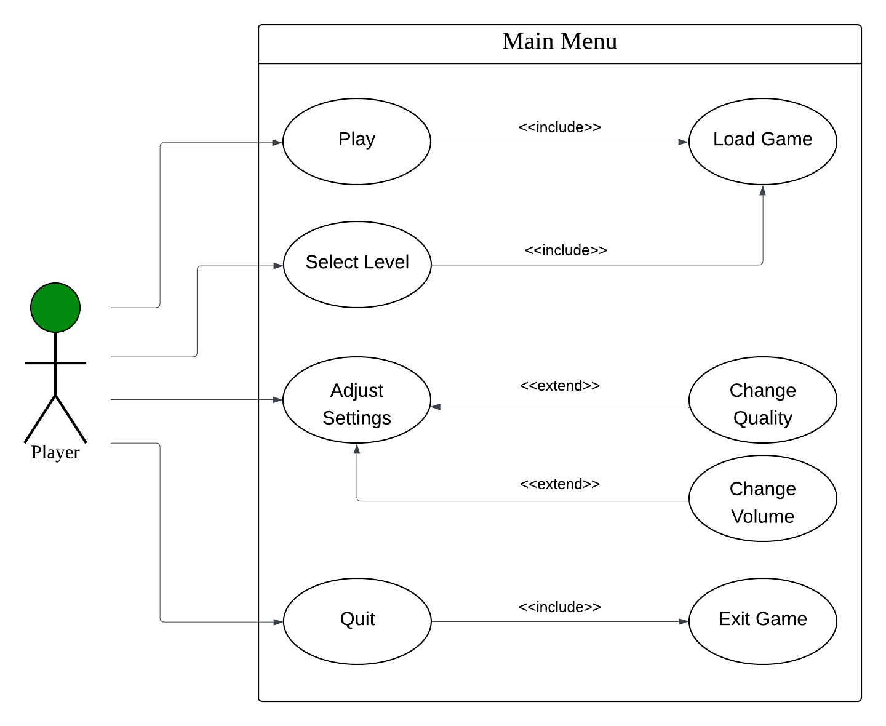

Figure 1: Main Menu Use-Case

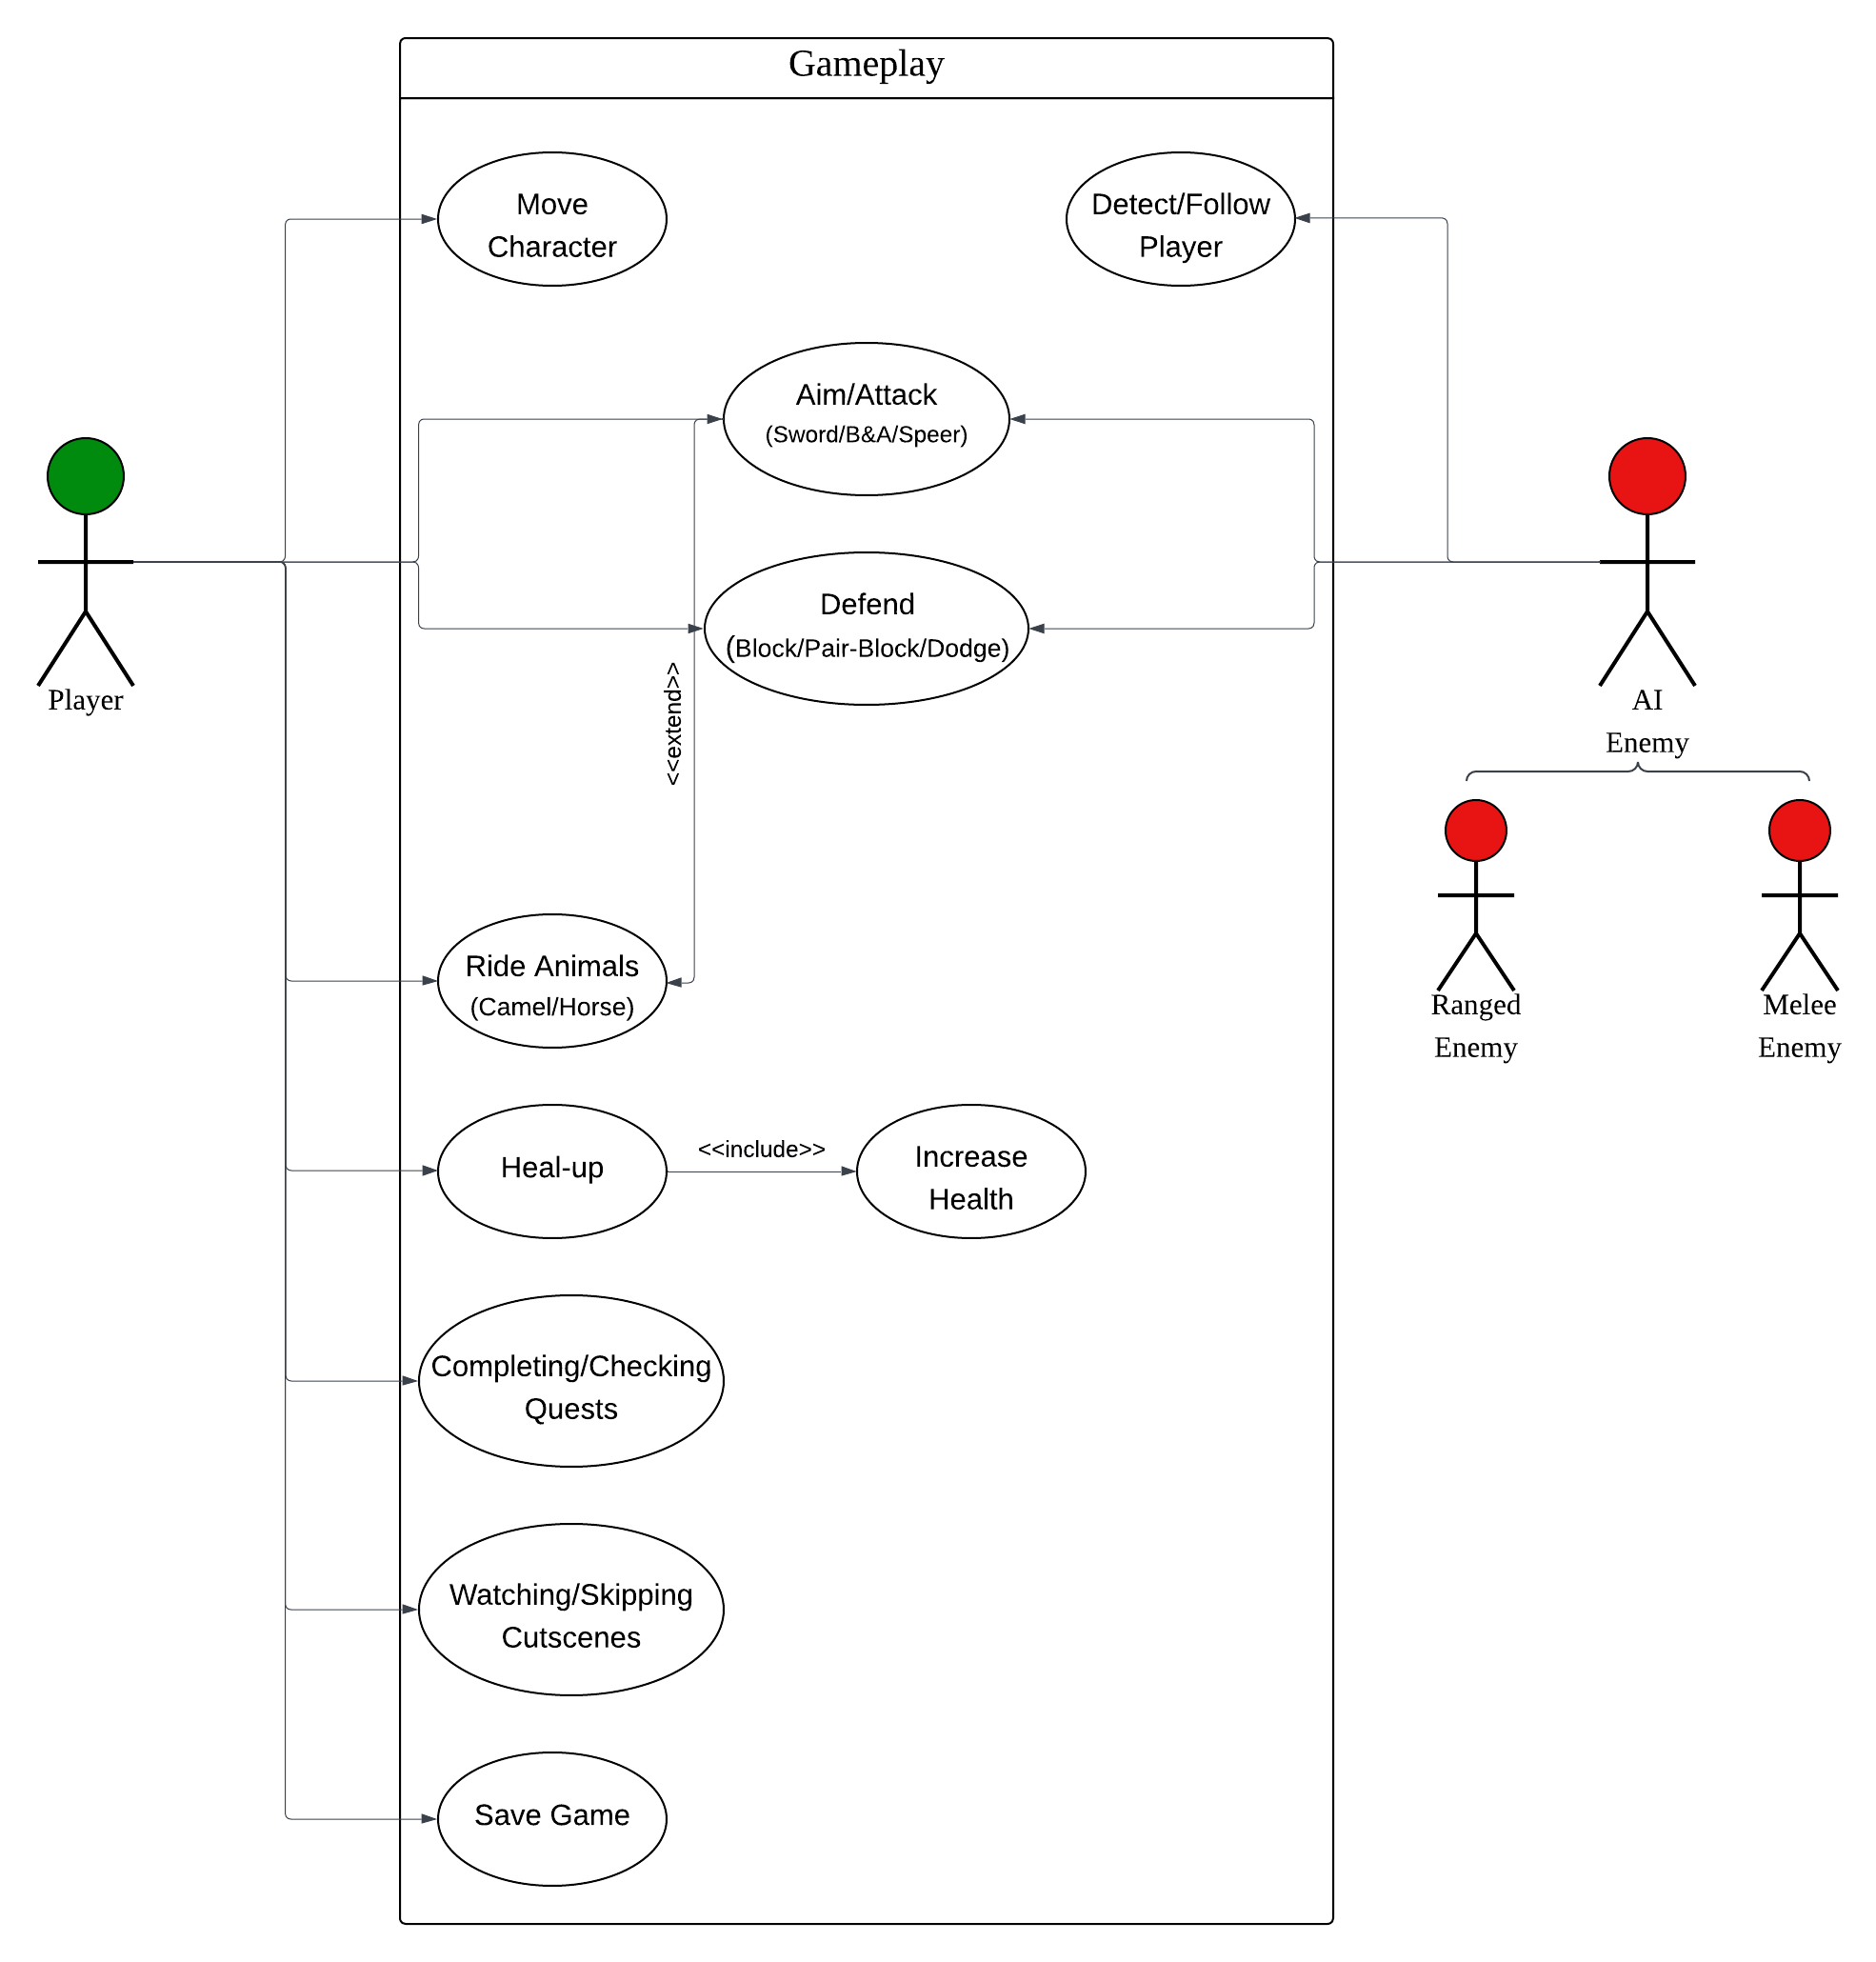

Figure 2: Gameplay Use-Case

* 1. **Use-Case Description**

Table 3: Main Menu Use-Case

|  |  |
| --- | --- |
| Main Menu | |
| US-MM-1: Play | |
| Actor | Player |
| Description | The player to start the game from beginning, or load the game from the last checkpoint |
| Pre-conditions | - Download the game  - Press Play |
| Post-conditions | - Play the game |
| US-MM-2: Select Level | |
| Actor | Player |
| Description | The player will be able to select a level and play the selected level from beginning |
| Pre-conditions | - Press Select Level  - Select a level  - The previous level should be completed |
| Post-conditions | - Play the game from selected level |
| US-MM-3: Adjust Settings | |
| Actor | Player |
| Description | The player will be able to adjust some settings like the quality and the volume of the game |
| Pre-conditions | - Press Settings  - Choose quality  - Adjust the volume scalar |
| Post-conditions | - Play the game with adjusted settings |
| US-MM-4: Quit | |
| Actor | Player |
| Description | The player will be able exit the game |
| Pre-conditions | - Be in Main Menu  - Press Quit |
| Post-conditions | - Exit the game |

Table 4: Gameplay Use-Case

|  |  |
| --- | --- |
| Gameplay | |
| US-G-1: Move Character | |
| Actor | Player |
| Description | The player will be able to walk or sprint with the character |
| Pre-conditions | - Be in the level  - Not being in a cutscene |
| Post-conditions | - Move the character |
| US-G-2: Aim/Attack | |
| Actor | Player/Enemy |
| Description | Both player and enemy will be able to aim/attack the other using sword, b&a, spear |
| Pre-conditions | - Using weapon  - The enemy should be in a certain distance |
| Post-conditions | - Aim/Attack and damage the other |
| US-G-3: Defend | |
| Actor | Player/Enemy |
| Description | Both player and enemy will be able to defend in 3 systems which are block, pair-block, dodge |
| Pre-conditions | - Using weapon  - Block at the correct time for pair-block  - Sprint to dodge |
| Post-conditions | - Defend |
| US-G-4: Detect/Follow Player | |
| Actor | Enemy |
| Description | The enemy will be able to detect the player and chase him |
| Pre-conditions | - See the player  - Being in a certain distance |
| Post-conditions | - Chase the player |
| US-G-5: Ride Animals | |
| Actor | Player |
| Description | The player will be able to ride animals and move and attack from them |
| Pre-conditions | - Being close to an animal |
| Post-conditions | - Ride an animal and move and attack from them |
| US-G-6: Completing/Checking Quests | |
| Actor | Player |
| Description | The player will be able to check the active and completed quests |
| Pre-conditions | - Open quests lists |
| Post-conditions | - Check the quests |
| US-G-7: Watching/Skipping Cutscenes | |
| Actor | Player |
| Description | The player will be able to watch or skip the cutscene |
| Pre-conditions | - Being in a cutscene |
| Post-conditions | - Watch the cutscenes  - Press ‘X’ to skip |
| US-G-8: Save Game | |
| Actor | Player |
| Description | The player will be able to save the game to continue from it the next time he plays the game |
| Pre-conditions | - Pause the game  - Press save |
| Post-conditions | - Save the game |

1. **Implementation**

## **Menus:**

Figure 3: Main Menu

This is the Main Menu, it contains animated background and 3 buttons which are:

1. Play: Here you can play the game.
2. Settings: Here you can adjust some settings.
3. Quit: Here you can exit the game.

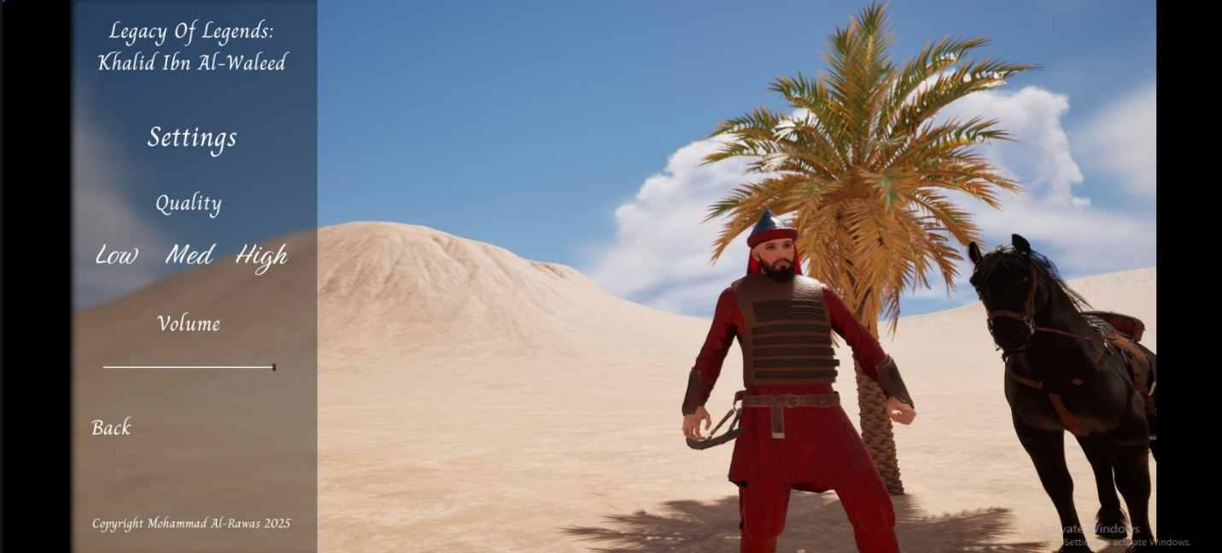

Figure 4: Settings Menu

This is the Settings Menu, where you can adjust:

1. Quality: By pressing the quality button you want.
2. Volume: By settings the volume scale as you want.

Figure 5: Pause Menu

Here is the Pause Menu, it contains some information about Khalid in the right like his name, some important dates, and general information about him. Also, the menu contains 4 buttons:

1. Resume: Where you can continue playing the game.
2. Save: Where you can save your progress.
3. Settings: Where you can adjust some settings like the quality and volume.
4. Quit: Which will take you to the Main Menu.

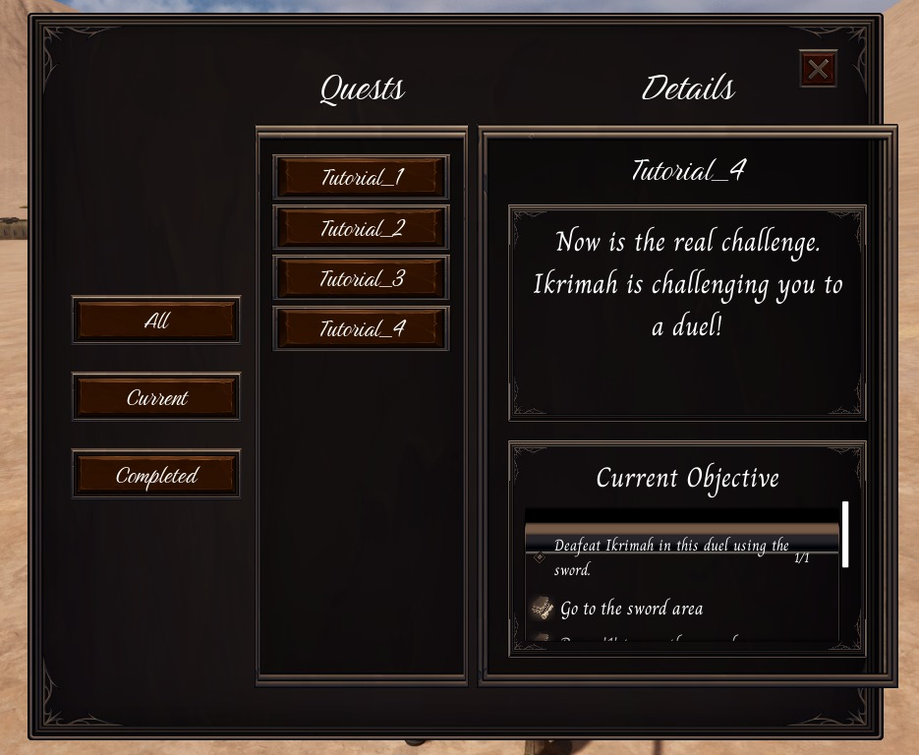

Figure 6: Quest List Menu

Lastly is the Quest Menu. Here you can check the current and completed quests information like the description and objectives.

* 1. **Gameplay:**

Figure 7: In-Game Screen 1

This is the in-game screen. Beside the game, you can see your health bar, new or completed quest notification, and the quest list.

Figure 8: In-Game Screen 2

Here is another in-game screen, but this one shows the map more. We can see that there are some buildings and terrain like:

1. Houses
2. Kaaba
3. Gathering House
4. Idols
5. Mountains
6. Trees
7. Wills

Also, we can see some NPCs like:

1. The NPCs who pray in front the idols.
2. The NPCs who move around the Kaaba.
3. The NPCs who sit under the tree and think.
4. The NPCs who are sitting and doing trades in the bazaar.

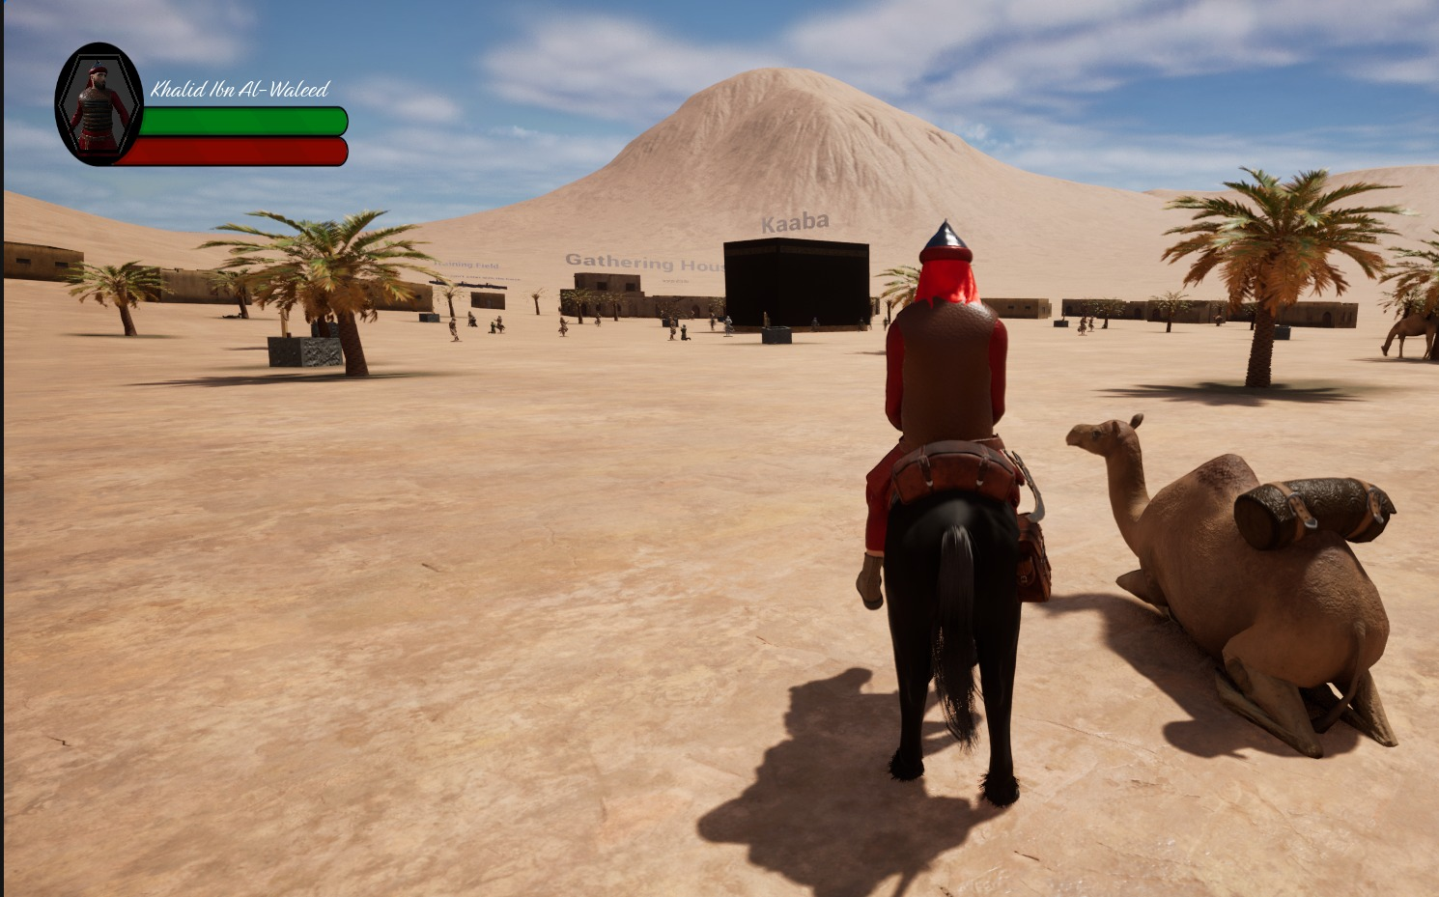

Figure 9: Horse

Figure 10: Camel

From figures 9 and 10, we can see that we can interact with animals by riding them and move around the map with them.

Figure 11: Location-Based Quest

Now to the quest system. There are two types of quests and one of them is the location-based quests, this type of quests requires to go to a location to complete them.

Figure 12: Combat-Based Quest

The second type of quests is the combat-based quests. Here you have to defeat the enemies in order to complete the quest.

Figure 13: Cutscene

After completing a quest, a comic book based cutscene will show up. As you can see, there is the subtitles under the images. Also you can press ‘X’ to skip the cutscene.

Figure 14: Quest Completed Notification

Lastly. When you complete a quest, a notification will pop up informing you that you completed the quest.

1. **Conclusion**
   1. **Game Summary:**

It is an RPG game about the life-story of Khalid Ibn Al-Waleed.

It was made by Unreal Engine, and the purpose of the game is to teach the new generation about the historical life of one of the greatest commanders ever and have the chance to play and experience his legendary career.

To complete the game you, have to do the required quests whether it is location-based or combat-based quest so you can experience the correct story of our legendary hero.

* 1. **Key Findings:**

Since it is difficult to make an RPG game solo, I faced many and many problems, but I always found a solution to solve the problems and develop the game:

Problem:

First problem I faced was in creating clothes for the characters, it sounds easy, but definitely it wasn't at all since it is hard to find clothes related to old Arab life and attach shields on them.

Solution:

I found a software that helps in creating clothes which is Marvelous Designer, I learned how to use it and made old Arabic clothes. Then I used blender to attach the clothes to the characters and then attach the shields and equipment.

Problem:

Each character has different bones from the other, this caused the animations to not work properly on every character.

Solution:

I tried to make each character have the same bones by retargeting them using powerful tool in Unreal Engine which is IK rigs and then transformed the animations to work with different bones.

Problem:

Unfortunately, and since I don't have sensors which are expensive (3,000 USD), I couldn't make cinematic cutscenes.

Solution:

Since the cutscenes is important feature in the story games, I found another solution which is make them like a comic book cutscenes where it will show images rather the videos.

In the end, I learned many and many tools and ideas that is going to help me in my game development career such as:

- Plan a game

- Craft Game Design Document

- Critical thinking

- Improving my research skills to solve any problem

- Create characters

- Character animations and how to implement animations for different characters

- Editing animations

- Create clothes

- Create and design open world map

- Painting tools for immersive environments

- Add animals and interact with them

- Create NPCs

- Create advanced systems like traveling, combat, and quest systems

- Create different smart AI enemies using behaviour trees and inheritance

- Learned about the sounds especially Meta Sounds for audios

- The Niagara system for dynamic visual effects

- Cinematics and cutscenes

- Implementing UI

- Developing Main Menu

- Deploy and build the game

* 1. **Future Work:**

My plans for future are:

- Continue working on the game until I finish all chapters

- Improve the map to have better experiences

- Add more NPCs to bring more life to the game

- Adding select level function

- Adding save/load functions

- Improving the cutscenes

- Adding more languages like Arabic and Turkish

- Deploy and build the game so it can be ready to download on steam or itch.io